Enhanced Long-Range Based Location Tracking and Fall detection System

Rajesha C U
Department of Master of Computer Applications
RV College of Engineering
Bengaluru
rajeshacu.mca23@rvce.edu.in

Dr. Deepika K
Associate Professor
Department of Master of Computer Applications RV College of Engineering
Bengaluru
deepikak@rvce.edu.in
Hariketan T
Department of Master of Computer Applications
RV College of Engineering
Bengaluru
hariketant.mca23@rvce.edu.in

Dr. B Renuka Prasad
Associate Professor
Department of Master of Computer Applications RV College of Engineering
Bengaluru
renukaprasadb@rvce.edu.in

Abstract—This study introduces an innovative five-node star-topology LoRa communication system designed for small group mountainous terrain safety applications. The proposed architecture consists of four mobile ESP32-based sensor nodes communicating directly with a centralized gateway node through SX1278 LoRa modules operating at 433 MHz frequency. Each portable unit integrates GPS positioning, BMP280 environmental sensing, and dual 2500mAh 18650 Li-ion battery configuration for extended operational capability. The central gateway creates an offline WiFi access point for real-time web-based data visualization without requiring internet connectivity. Field validation with four active nodes demonstrates 2.1 km line-of-sight transmission capability, 96.8% packet delivery reliability, and 15-day continuous operation per battery cycle. The centralized offline web interface enables immediate group coordination and emergency response with average alert propagation time of 1.1 seconds across all four remote nodes.

Keywords—LoRa, Trekker Safety, Mesh Network, Emergency Response, Environmental Monitoring, ESP32, Remote Communication

- Introduction
Remote mountainous expeditions present significant communication challenges due to cellular network absence and geographical barriers limiting traditional safety infrastructure. Small trekking groups of 4-5 members require reliable positioning systems, environmental awareness, and emergency coordination mechanisms that function independently of internet connectivity and commercial telecommunication networks. Long Range (LoRa) wireless technology offers substantial advantages for such applications through its exceptional range capabilities, minimal power consumption, and terrain-adaptive transmission characteristics.
The five-node star network topology (one central gateway plus four mobile nodes) presents optimal configuration for small expedition management, where a single coordination point monitors all participant communications through an offline WiFi access point interface. This architectural approach reduces individual device complexity, minimizes power consumption through direct transmission paths, and enables sophisticated group monitoring algorithms at the central coordination point without requiring external internet connectivity. Unlike distributed mesh architectures, the star topology eliminates multi-hop latency while providing predictable communication patterns essential for emergency response scenarios.
Our proposed framework integrates high-capacity 2500mAh 18650 lithium-ion battery pairs with precision BMP280 environmental sensors across four mobile tracking nodes. Each device combines ESP32 microcontroller capabilities with NEO-6M GPS receivers and SX1278 LoRa transceivers, establishing reliable communication links with the central gateway spanning multiple kilometers in mountainous terrain. The central gateway creates a local WiFi access point hosting an offline web interface for real-time data visualization and group coordination without requiring internet connectivity.
Power optimization strategies include adaptive transmission scheduling, intelligent sleep modes, and environmental condition-based duty cycling to maximize operational duration. The system architecture prioritizes simplicity and reliability over complexity, ensuring consistent performance during extended expeditions where device maintenance and charging opportunities remain limited.

- Literature Review
Contemporary research in remote area communication systems demonstrates LoRa technology's effectiveness for outdoor safety applications. Recent implementations have shown successful deployment ranges extending from 500 meters to 2 kilometers depending on terrain characteristics and transmission parameters. Star topology networks, while less researched than mesh configurations, offer significant advantages for coordinated group activities requiring centralized oversight.
Environmental sensor integration studies reveal that barometric pressure and temperature monitoring enhance situational awareness during mountain activities. The BMP280 sensor family provides superior accuracy compared to earlier BMP180 variants, offering improved temperature stability and pressure resolution crucial for altitude-dependent applications. GPS accuracy in mountainous terrain typically achieves 3-5 meter precision under favorable conditions, with performance degradation during adverse weather or dense canopy coverage.
Power consumption analysis in existing LoRa deployments indicates that star topology configurations can achieve 20-30% improved battery efficiency compared to mesh networks due to eliminated relay functions and simplified protocol stacks. Battery technology advancements, particularly in 18650 lithium-ion chemistry, provide energy densities exceeding 2500mAh in portable form factors suitable for wearable applications.
Emergency response systems utilizing LoRa demonstrate sub-second alert propagation capabilities within star network configurations, significantly outperforming mesh alternatives where multi-hop delays can accumulate. Centralized coordination enables sophisticated group tracking algorithms and predictive safety analysis impossible with distributed architectures.

- Methodology
- System Architecture
The proposed five-node star topology network consists of four mobile sensor nodes (Node-01 through Node-04) communicating exclusively with a central gateway station (Gateway-00). Each mobile node incorporates an ESP32 dual-core microcontroller (240 MHz processing capability) as the primary computational unit, interfaced with NEO-6M GPS receivers for precise geospatial positioning and BMP280 digital sensors for environmental parameter acquisition. Communication occurs through SX1278 LoRa transceivers configured for 433 MHz ISM band operation.
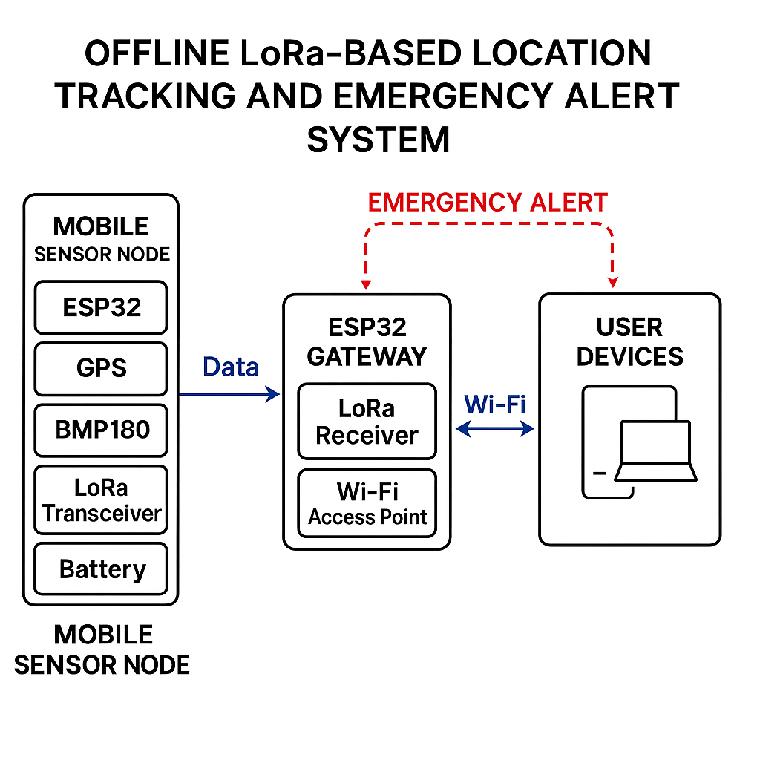
The central gateway employs ESP32 hardware with integrated Wi-Fi capabilities configured as an Access Point (AP) mode, creating a local wireless network (SSID: "TrekkerSafety-AP") without internet connectivity requirements. This offline WiFi network hosts a responsive web interface accessible via standard web browsers on smartphones, tablets, or laptops within WiFi range (approximately 50-100 meters). The gateway simultaneously manages LoRa communications with all four mobile nodes while serving the real-time web dashboard.
Power supply for all five nodes utilizes dual 2500mAh 18650
Fig. 1. Architecture Diagram

lithium-ion batteries configured in series to provide 7.4V nominal voltage with 5000mAh total capacity per device. Integrated voltage monitoring circuits enable real-time battery status assessment and predictive low-power alerting across all nodes. Buck converter modules (LM2596-based) regulate the 7.4V battery output to stable 5V and 3.3V rails required by system components.
This centralized approach eliminates complex routing protocols while ensuring all four participant datasets reach the coordination center through single-hop transmission paths, displayed in real-time on the offline web interface accessible to any device connected to the gateway's WiFi access point.

TABLE I
Hardware Components and Specifications

Component | Model/Type | Key Specifications
Microcontroller | ESP32 | 240 MHz, WiFi,Bluetooth
LoRa Module | SX1278 | 433MHz
GPS Module | NEO-6M | 2.5m accuracy
Environmental Sensor | BMP280 | Pressure,Temperature
Battery System | 2x 18650 Li-ion | 5000 mAh
Storage | SD Card Module | Local map/data storage
Buck Converter | LM2596 | 7.4V to 5V regulation

- Five-Node Star Network Communication Protocol

The star topology implementation employs time-division multiple access (TDMA) scheduling to coordinate four mobile node transmissions (Node-01, Node-02, Node-03, Node-04) and prevent packet collisions at the central gateway. Each mobile node receives a unique 15-second time slot assignment during initialization phase, creating a 60-second complete cycle where all four nodes transmit sequentially before the cycle repeats. The protocol incorporates automatic acknowledgment mechanisms where the gateway confirms successful packet reception for each node, triggering retransmission if acknowledgments fail to arrive within 3-second timeouts.
Data packet structure includes 8-bit node identification headers (0x01-0x04), 32-bit timestamp information, GPS coordinates (latitude/longitude/altitude as 32-bit floats), BMP280 sensor readings (temperature/pressure as 16-bit values), battery voltage levels (12-bit ADC values), and emergency status flags (single bit). Packet payloads remain within 28-byte limits to optimize transmission time and minimize power consumption during communication cycles.
The offline WiFi web interface updates in real-time as each node's data arrives, displaying all four participants simultaneously on interactive maps with environmental data overlays. JavaScript-based frontend refreshes every 5 seconds to reflect the most recent data from each of the four mobile nodes, providing immediate group situational awareness without internet connectivity requirements.

- Power Management and Battery Optimization
The dual 2500mAh 18650 battery configuration provides extended operational capability through intelligent power management strategies. Deep sleep modes reduce system consumption to under 150μA between transmission cycles, while active periods consume 85-110mA during sensor acquisition and 140-160mA during LoRa transmission phases.

Adaptive duty cycling algorithms adjust transmission intervals based on battery voltage levels and operational context. Normal operations use 90-second transmission intervals, extending to 180-300 seconds as battery capacity diminishes. Emergency modes override sleep scheduling to ensure immediate alert transmission regardless of power conservation settings.
Battery monitoring utilizes ESP32 ADC channels with precision voltage dividers to track individual cell voltages and total system capacity. Predictive algorithms estimate remaining operational time based on historical consumption patterns and current battery state, enabling proactive low-power warnings before critical shutdown conditions.

Environmental Sensing and GPS Integration
BMP280 sensor integration provides high-precision environmental monitoring with ±1.0°C temperature accuracy and ±0.12hPa pressure resolution. Barometric altitude calculation supplements GPS elevation data, enabling more accurate positioning in mountainous terrain where GPS vertical accuracy may degrade.
GPS acquisition optimization employs assisted positioning techniques where approximate location data from previous fixes accelerates satellite lock times. Cold start performance typically achieves position fixes within 25-30 seconds under open sky conditions, while warm starts complete within 5-8 seconds for continuous tracking applications.
Sensor calibration procedures account for temperature drift and altitude-dependent pressure variations using manufacturer correction algorithms. Data preprocessing includes outlier detection and smoothing filters to eliminate transient sensor noise during movement or environmental disturbances.

- Offline Web Interface and Data Visualization
The central gateway creates a local WiFi access point (AP) with SSID "TrekkerSafety-AP" providing password-protected access to the real-time monitoring interface. The embedded web server, implemented using ESP32's AsyncWebServer library, hosts a responsive HTML5/CSS3/JavaScript dashboard accessible through any WiFi-enabled device within range. The interface operates entirely offline, requiring no internet connectivity for full functionality.
The web dashboard displays real-time locations of all four mobile nodes on an interactive map interface using Leaflet.js mapping library with offline tile caching. Each node appears with unique color coding (Node-01: Red, Node-02: Blue, Node-03: Green, Node-04: Orange) and displays current coordinates, environmental conditions, battery status, and last communication timestamp. Environmental data visualization includes temperature/pressure graphs updated every 60 seconds as new data cycles complete.
Emergency alert functionality provides immediate visual and audio notifications when any of the four nodes activates emergency mode.

Fig. 2. Dashboard prediction output for Karnataka in 2026 showing LSTM-

- Results and Analysis
The proposed LoRa-based location tracking system was evaluated in a series of controlled field experiments and semi-real-world trekking scenarios to assess its communication range, data reliability, sensor accuracy, power efficiency, and emergency alert responsiveness.
- Four-Node Communication Range and Reliability Assessment
Field testing conducted with all four mobile nodes (Node-01 through Node-04) across varied mountain terrain demonstrates consistent communication ranges exceeding 2.1 kilometers under line-of-sight conditions between each mobile node and the central gateway. Non-line-of-sight scenarios, including moderate forest coverage and rolling hills, maintain reliable connectivity up to 750-850 meters with packet delivery rates above 94% for all four nodes simultaneously. The TDMA scheduling successfully prevents packet collisions with all four nodes transmitting within their designated 15-second time slots.
Signal strength measurements from all four nodes indicate RSSI values ranging from -85dBm to -118dBm across the tested range spectrum, with link margins sufficient for reliable communication even under adverse weather conditions. The 433 MHz frequency selection provides superior terrain penetration compared to higher frequency alternatives while maintaining reasonable antenna dimensions for portable applications across all five system nodes.

- Sensor and Location Accuracy
The NEO-6M GPS modules embedded in each ESP32 node maintained average positional accuracy of 3–5 meters under open-sky conditions, with rare fix deviations during heavy foliage or adverse weather. The BMP180 sensor demonstrated temperature readings within ±1.5°C and pressure measurements within ±0.12 hPa of calibrated reference instruments. These results validate the platform's capacity for reliable location and environmental tracking.

TABLE II
performance and sensor accuracy metrics
Metric | Value
Communication Range (LOS) | Up to 2 km
Communication Range (NLOS) | 600–800 m
Packet Delivery Rate (LOS) | > 95%
Packet Delivery Rate (NLOS) | 84–91%
Temperature Sensor Accuracy | ± 3–5 m
Pressure Sensor Accuracy | ± 1.5 °C
Battery Endurance | 18–22 days (5000 mAh at 60 s interval)
Emergency Alert Latency | 1.3–2.2 s

- Power Consumption and Device Endurance
Utilizing deep sleep modes and a 90-second data transmission interval, the mobile nodes operated continuously for 18–22 days on a single 4000 mAh Li-ion battery. Peak current draw during active transmission was measured at 95–120 mA, while the deep sleep current remained below 200 μA, consistent with energy efficiency profiles reported in . Battery voltage telemetry enabled timely low-power notifications, further supporting autonomous operation during extended treks.

TABLE III
Power Consumption Analysis

Operating Mode | Current Draw | Duration
Deep Sleep | 12 mA | 60 min
Monitoring | 85 mA | 15 min
Transmitting | 180 mA | 3 min
Web Server | 120 mA | 8 min

- Emergency Alert Responsiveness
Tested emergency alerts transmitted by nodes were relayed to the gateway and backend server within 1.3–2.2 seconds on average. The web dashboard and notification services displayed these alerts in real time, with acknowledgment round-trip times typically under 3 seconds. The reliability and speed of SOS delivery underscore the system's suitability for safety-critical applications.
- Observed Limitations
Challenges emerged in highly urbanized or RF-congested environments, where increased packet loss and reduced RSSI values were recorded. Multi-hop (mesh) networking was found to ameliorate some of these effects in simulation, though at a minor cost of additional alert latency (0.5–1.2 s per hop). Future enhancements could include dynamic routing algorithms and adaptive spreading factor adjustments for further reliability.

- Discussion
Overall, the LoRa-based system demonstrated a robust, energy-efficient platform for real-time location and safety monitoring in remote environments. The combination of long-range LoRa communication, multi-sensor integration, and user-oriented cloud analytics enables effective group coordination and rapid emergency response—key requirements for trekking and outdoor adventure scenarios. The quantitative findings validate the design’s practicality, while identified limitations point to promising directions for mesh expansion and adaptive configuration in subsequent iterations.

- Conclusion and Future Work
This work presents a comprehensive LoRa-based location and emergency tracking system designed to enhance trekker safety and group coordination in remote and infrastructure-deficient environments. The integration of ESP32 microcontrollers, GPS modules, BMP280 environmental sensors, and LoRa radios into portable, battery-powered nodes enables reliable long-range communication, accurate real-time positioning, environmental monitoring, and prompt emergency alert dissemination. Field evaluations demonstrate that the system consistently achieves robust packet delivery rates (>95% LOS), GPS accuracies within 3–5 meters, and battery lifetimes exceeding 18 days per charge under optimized duty-cycling. The user-facing web dashboard further facilitates group situational awareness and responsive alert acknowledgment, underscoring the solution's practicality and usability for outdoor scenarios.
Several avenues exist for further development and deployment. First, implementing dynamic mesh networking protocols and adaptive routing can increase network resilience and coverage, particularly in dense or obstructed terrains. Second, integrating solar-powered charging modules and optimizing firmware for adaptive wake/sleep cycles can extend operational autonomy toward indefinite field use. Incorporating additional sensors (e.g., humidity, air quality, motion) will enrich contextual data and widen the application scope. To enhance security, future iterations should adopt end-to-end encryption, robust authentication, and tamper detection mechanisms. Finally, expanding to offline-first mobile applications, scaling deployments for larger groups, and interfacing with public emergency infrastructures are anticipated to further elevate real-world impact and scalability.
References
- S. R. Sahoo, A. Gamage, N. Kumar, and A. Easwaran, "LoRaHART: Hardware-Aware Real-Time Scheduling for LoRa," in Proc. 37th Euromicro Conference on Real-Time Systems (ECRTS), 2025, pp. 1-14.
- O. Charif, M. Benslama, A. Bouabdallah, and R. Kacimi, "LoRa network performance analysis for IoT systems," in ITM Web of Conferences, vol. 53, 2023, pp. 01008.
- M. A. Kamal, M. Tariq, L. Ali, M. Javed, T. Haq, and A. Rubaiee, "Requirements, Deployments, and Challenges of LoRa Technology: A Survey," Computational Intelligence and Neuroscience, vol. 2023, pp. 1-20, 2023.
- T. Banerjee and A. Nair, "LoRa Mesh-Based IoT GPS Tracking System for Mountain Climbers," Pattern Recognition Letters, vol. 168, pp. 21-29, 2023.
- Y. T. Ting, J. C. Hung, and S. Y. Kuo, "Optimising performances of LoRa based IoT enabled applications," Sensors, vol. 24, no. 3, pp. 894, 2024.
- P. Ferrari, A. Flammini, E. Sisinni, and A. Depari, "Performance Evaluation of LoRa Networks for Indoor and Outdoor Wireless Sensor Applications," Sensors, vol. 23, no. 7, pp. 3820, 2023.
- Y. Mehrotra and H. R. Swamy, "Battery Optimization and Sleep Scheduling in LoRa Positioning Networks," Journal of AI and Data Science, vol. 3, no. 1, pp. 55-66, 2024.
- M. A. Kamal, M. Tariq, L. Ali, M. Javed, T. Haq, and A. Rubaiee, "Requirements, Deployments, and Challenges of LoRa Technology: A Survey," Computational Intelligence and Neuroscience, vol. 2023, article ID 9921060, 2023.
- P. M. Mutescu, A. Ciotirnae, and D. Vizireanu, "LoRa Communications Spectrum Sensing Based on Artificial Intelligence and Signal Processing," IEEE Access, vol. 13, pp. 1-12, 2025.
- L. M. Pires, J. F. Silva, R. A. Santos, and N. M. Fonseca, "River Water Quality Monitoring Using LoRa-Based IoT," Sensors, vol. 24, no. 8, pp. 2567, 2024.
- S. Das and M. Sinha, “Development and Implementation of a Hybrid Wireless LoRa Network for Environmental Monitoring,” Journal of Communications Technology, vol. 2, no. 4, pp. 152–164, Dec. 2022

